Claryville Fire District
Draft Minutes June 4, 2024
The regular Meeting of the Board of Fire Commissioners of the Claryville Fire District was called to order at 6:31pm, June 4, 2024 at the Claryville Fire Department Warren Cole Hall.
Present: Tom Matthews, Terrry McNamara, and Mike Schiffer.
Representing the Fire Department: Chief Paul Metzger, Glenn VanDenBerg
Public: None
Minutes of the May 7, 2024 Meeting were read and approved Upon Motion by Terry, Seconded by Mike, None Opposed.
The Treasurer’s Report for June 4, 2024 was read an approved Upon Motion by Tom, Seconded by Tery, None Opposed.
Communication and Bills: The following Bills were approved for payment Upon Motion by Terry, Seconded by Mike. 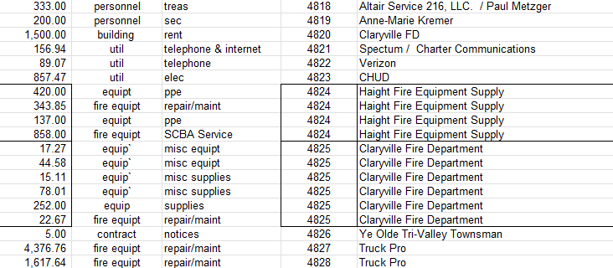
Fire Chief’s Report:
- Calls – 2 calls
5/1 Lift Assist – C. Breiner
5/2 – EMS Assist – Red Hill Knolls – OD
- Training
Mike led EVOC Class training with Mike V., Lou, and Said. Everyone passed.
Paul completed ICS-300.
Said and Mike V, attended Water Rescue Awareness.
Mike V. started IVO.
- Other
Only 2 drills in May – Equip check and Driver Training.
Engine Light is currently on in 32.
Annual Physicals are scheduled for 7/22.
Bloodborne Pathogens, CPR, and Harassment training is tentative for September.
Committee Report: No update on consolidation
Old Business: Don’t purchase the Fire Service Laws of New York State book, we have the Fire District Officer’s Gude which is comprehensive for our use. Approved Upon Motion by Tom, Seconded by Terry, None Opposed.
New Business: Paul will call to clear up questions about some invoices.
Comments from the Public: None
Adjournment at 7:00pm Upon Motion by Terry, Seconded by Mike.
Respectfully submitted,
Anne-Marie Kremer, Secretary

